Geostationary satellites could significantly contribute to the establishment of long-term time series of surface albedo thanks to their extensive historical archive. Meteosat first generation observations have been archived continuously since September 1983 which represents a data record of more than two decades. Additionally, their frequent acquisition cycle presents a twofold advantage for the retrieval of surface albedo: 1) it increases the possibility to observe clear-sky areas and 2) sequential accumulation of daily observations can be used to document radiative effects resulting from atmospheric scattering and surface anisotropy.
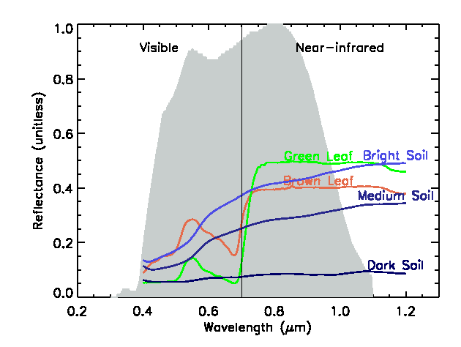
Spectral response of the VIS band onboard Meteosat-7 (Meteosat First Generation). Coloured lines show typical spectra of leaves and bare soils.

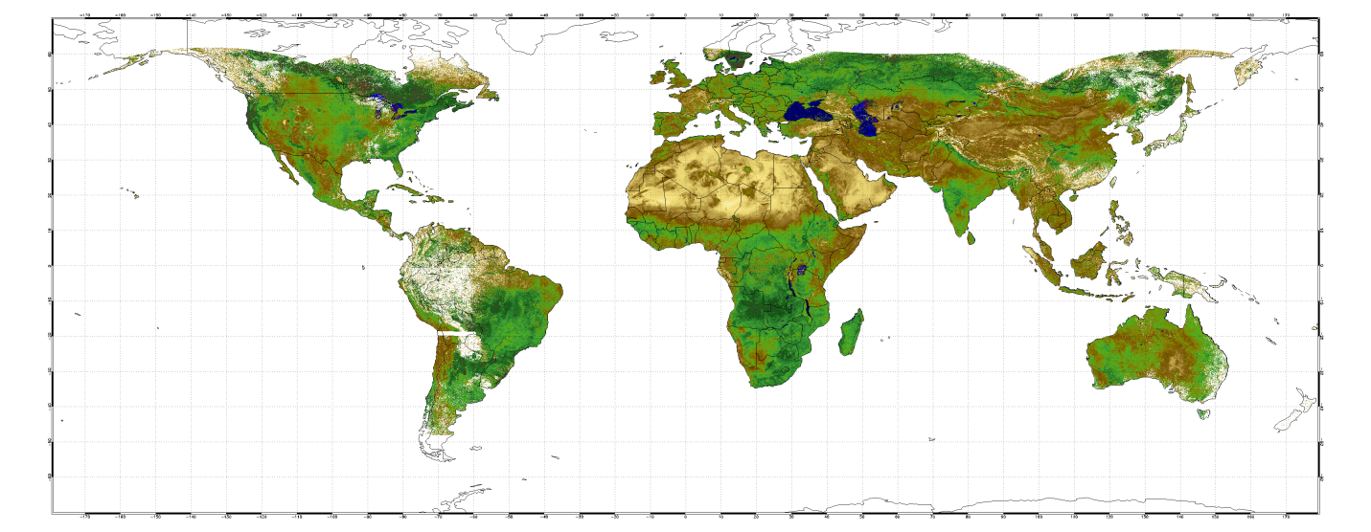

Data processing
The GSA algorithm can be used to derive surface albedo from any geostationary satellites observing the Earth in one or more solar channels as demonstrated in Govaerts et al. (2008). This algorithm has been implemented in the Operational reprocessing facility of EUMETSAT in order to generate reliable albedo dataset starting from 1982, through the analysis of data acquired by the six different Meteosat first generation platforms for the satellites located at the 0 degree longitude. Observations acquired by the EUMETSAT satellites located over the Indian Ocean since 1998 have also been processed. The GSA algorithm has also been implemented at the Japanese Meteorological Agency (JMA) for the processing of the GMS-5 archive. The GMS archive is going back to the mid-eighties but still requires to be calibrated prior to 1997. The GSA algorithm is also implemented at NOAAâ€™s National Climatic Data Center (NCDC). The GOES archive starts in 1978.

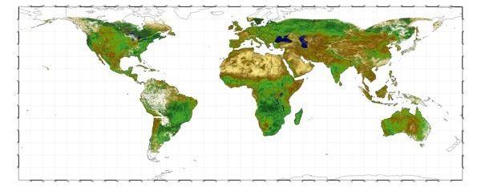

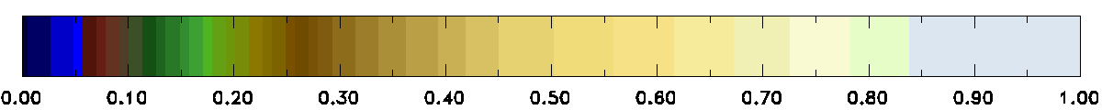
Example of gridded broadband surface albedo map derived with the GSA algorithm from Meteosat-5, -7, GMS-5 and GOES-8, -10 observations acquired on May 1-10, 2001 (click to enlarge).

