^{Review}
^{At issue:}
How to reduce pressure at any level to sea level pressure.
^{Needed the following:}
- ^{Ideal gas equation}
The ideal gas equation for n kilomoles of any gas is:
^{pV = nR*T}
If the pressure and specific volume of dry air are p_{d} and α_{d}, the ideal gas equation for dry air becomes:

p_{d}α_{d} = R_{d}T

Where R_{d} is the gas constant for
1 kg of dry air
For water vapor, it is:
eα_{v} = R_{v}T
Since the molecular weight of water is M_{w} = 18.016, and the gas constant for M_{w} kg of water vapor is R*, we have:
R_{v} = R*/M_{w} = 461 J deg⁻¹ kg ⁻¹
- Dalton’s Law

Air is a mixture of gases and according to Dalton’s Law of partial pressures-the total pressure exerted by a mixture of gases which do not interact chemically, is equal to the sum of the partial pressures of the gases.

- Hydrostatic Equation

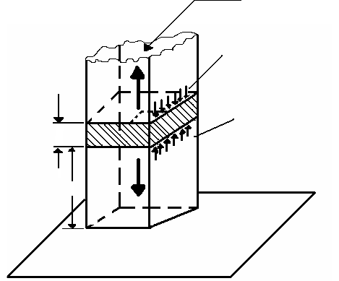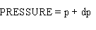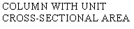
The net vertical force on the block due to the vertical gradient of pressure is upward and given by the positive quantity – dp as indicated in the figure. The balance of forces in the vertical requires that:

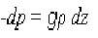

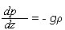

Since ρ = 1/α, the equation can be rearranged as:

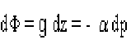

- The hypsometric equation
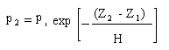
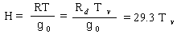

Geopotential Heigth

- The geopotential Φ at any point in the atmosphere is defined as the work that must be done against the earth’s gravitational field in order to raise a mass of 1 kg from sea level to that point.
- In other words, Φ is the gravitational potential for unit mass. The units of geopotential are J kg or m s . the force (in Newton’s) acting on 1kg at height z above sea level is numerically equal to g. the work ( in joules) in raising 1 kg from z to z + dz is g dz; therefore,

Where

